Final-TERM EXAMINATION

**Time Allowed: 60 Minutes** **Total Marks: 30**

**Note:**

* There are 16 problems, divided into two parts.
* Give a solution to each of the problems 1 to 10 in the file provided.
* Give a solution to each of the problems11 and 15 in an **linux and take screenshots**
* You must upload the files before the time is finished. Otherwise, no marks will be considered.

**Marking Scheme:**

* Problems 1 to 11, 10 * 1 = 11. There are no partial marks.

Problems 12 to 14, 3* 3 = 9 . There are partial marks depending on the correctness of the solution

Problems 15 to 16, 2 * 5 = 10 . There are partial marks depending on the correctness of the solution

|  |  |
| --- | --- |
| **Student First Name:** | Qingjun |
| **Student Last Name:** | Bao |
| **Student ID:** | 222-8801 |

***Part1 MCQ***

B 1- To install new software on Linux, we need:

A) to be on kernel mode and user privileged

B) to be on user mode and super privileged

C) to be on kernel mode and super privileged

D) to be on user mode and user privileged

D 2- Which of the following process state will be switched from “ready” state?

A) ready

B) terminated

C) waiting

D) running

A 3- The text editors are running under

A) supervisor mode and user mode

B) kernel mode and privileged mode

C) physical mode and logical mode

D) user mode and kernel mode

D 4- Which of the following will trigger an interrupt?

A) kernel function

B) software execution

C) CPU execution

D) I/O completion

A 5- What is the block sequence for best fit allocation algorithm for following memory and process structure. Start count from block number 1.

Empty block sizes = [100, 450, 200, 300, 400, 425]

Process size = [100, 212, 417, 112, 426]

A){1, 4, 6, 3,2}

B){1, 3, 5, 4,2}

C){1, 4, 2, 3, 6}

D){1, 4, 5, 3,2}

C 6- The list of processes waiting to execute on a CPU is called a(n) ____.

A) standby queue

B) device queue

C) ready queue

D) interrupt queue

A 7- The operator __ is used to redirect the output of a command to the file by erasing all existing data of that file.

A)>

B)>>

C)>>

D)<>

B 8- An address generated by a CPU is referred to as a ____.

A) physical address

B) logical address

C) post relocation register address

D) Memory-Management Unit (MMU) generated address

B 9- What is the internal fragment ?

A) total memory space exists to satisfy a request, but it is not contiguous

B) allocated memory may be slightly larger than requested memory

C) unallocated memory may be slightly larger than requested memory

D) partial of memory space exists to satisfy a request, but it is not contiguous

D 10-Which option of ls command used to view file inode number  
A) –l  
B) -o  
C) –a  
D) –i

C 11- Which of the following statement is FALSE ?  
a) Unix supports multiple users  
b) Linux is an open source operating system and the source code is shared  
c) Shell takes care of inter process communication  
d) Shell provides the feature of I/O Redirection

Part2 lab

12-Write a c++ code to create a parent and a child process, print out ‘’Hello from the parent” then write the parent ID, or “Hello from the child” and write the child ID.

**#include<iostream>**

**#include<stdio.h>**

**#include<string.h>**

**#include<stdlib.h>**

**#include<unistd.h>**

**int main(int argc, char*argv[]) {**

**int pid = fork();**

**if (pid == -1) {**

**printf("Error to create new process!\n");**

**return -1;**

**} else if (pid == 0) {**

**printf("Hello from the Parent! PID = %d\n", pid);**

**} else {**

**printf("Hello from the Child! PID = %d\n", pid);**

**}**

**return 0;**

**}**

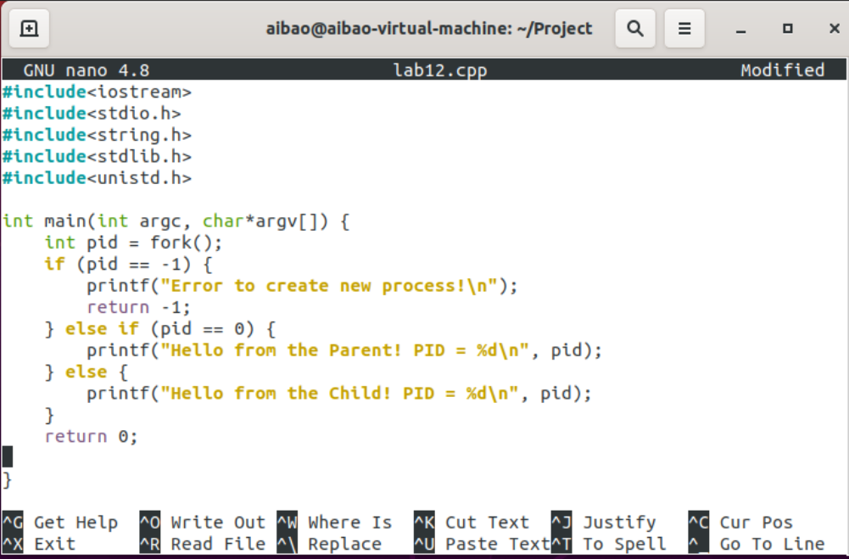

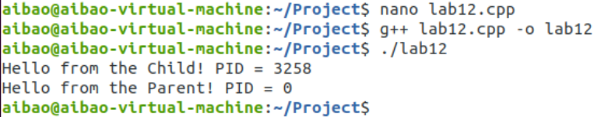

1. Create a file (file1) then kill it in both soft and hard kill.

* Go to tty4 then create a file1 write ”Hello this is a Linux class”
* go to tty3 and find this process then kill it
  + use the soft kill
  + use the hard kill

Step 1 : Go to tty4

Alt + F4

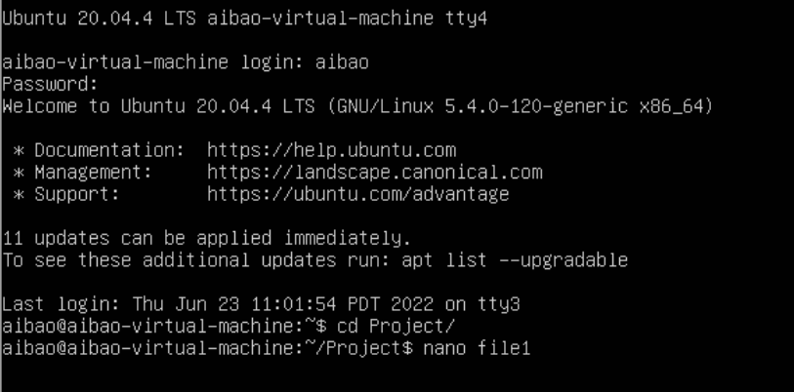

Step 2 : create a file1 write ”Hello this is a Linux class”

$ nano file1

Ctrl+O save the file1

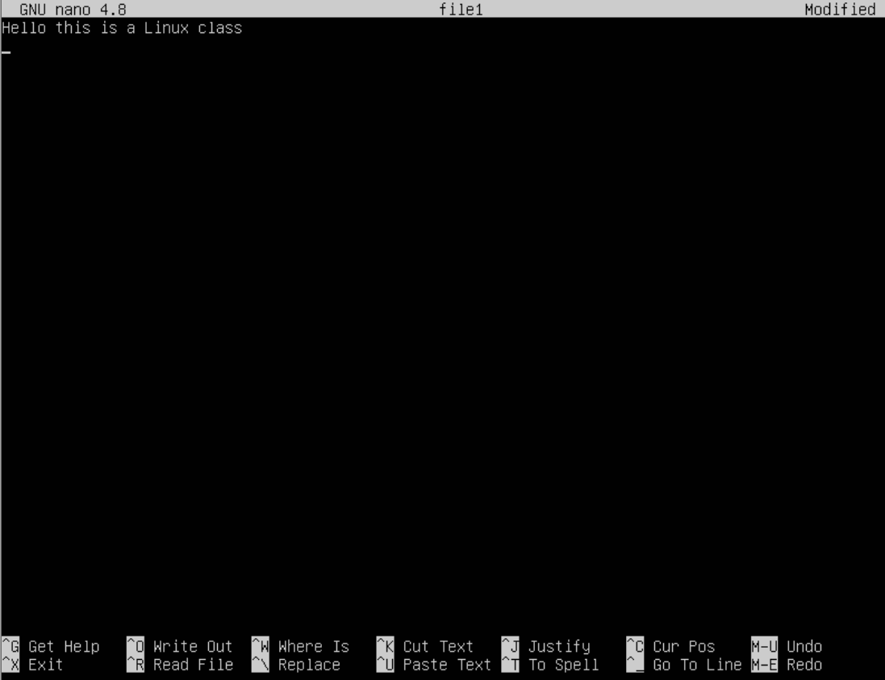

Step 3 : Go to tty4

Alt + F3

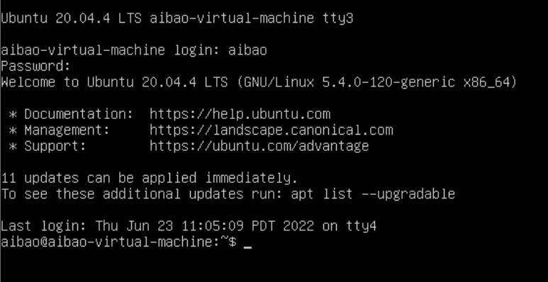

Step 4 : find this process

$ ps –ef | grep nano

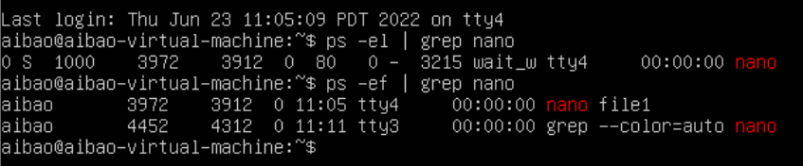

Step 5 : use the soft kill

$ kill -15 pid

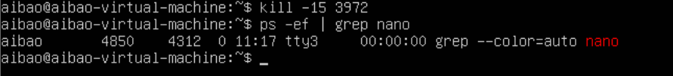

Step 6 : use the hard kill

Alt + F3 back to tty3

$ nano file1

Alt + F4 return to tty4

$ kill -15 pid

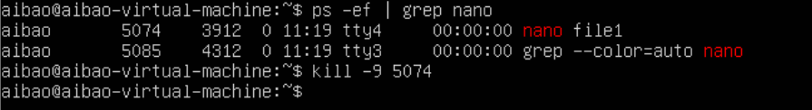

1. Create a file in your desktop, copy some data inside then, use two different ways to compress this file, an measure the time taken by each method

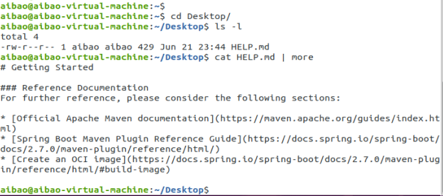

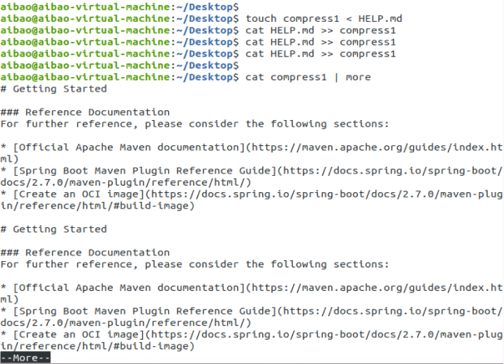

$ gzip

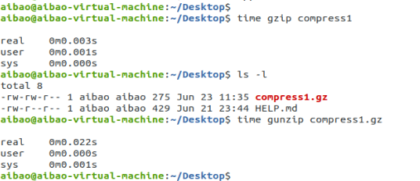

$ bzip2

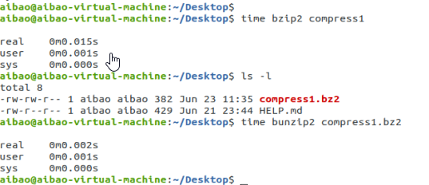

1. Using the shell script to create filenew in your desktop, then in the same script use the if-else statement to write :

“This is a linux class” 🡺 if the subject code is 10

“This is a java class ”🡺 if the subject code is 20

Then abend “Thank you”

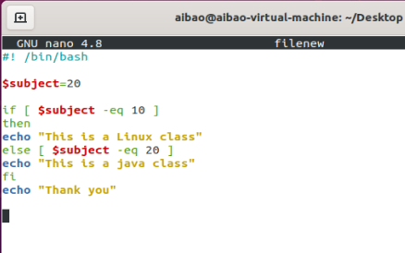

1. Using the Perl script, write a script using for loop to get the names and the prices of 3 items, then print the name and the price plus the tax in a separate line

Example: what is the item name? laptop

What is the item price? 1000

Laptop is 1150

#/usr/bin/perl

Print(“what is the item name?”);

$name=<STDIN>;

Print(“What is the item price?”);

$price=<STDIN>;

Print($name,“is”,$price);

